**Diurnal Cycle of Atmospheric CO2 in the Troutdale Suburban Area**

**Introduction:**

The diurnal cycle of CO2 is mainly driven by the Atmospheric Boundary Layer Height (ABLH), CO2 biospheric cycle and the proximity to urban CO2 emissions (Xeuref-Remy et al, 2018). The ABLH changes throughout the day where it is lowest at night and highest during the day, with the height being at the heat of the day. This is due to the incremental expansion of gas in the atmosphere as it warms and cools. As the gas cools and condenses, the concentration of atmospheric CO2 increases. This is the basis of the diurnal cycle of CO2, but it can get a lot more difficult as complexity is added to the model.

This project was done in two parts. Firstly, the analysis of already gathered CO2 data from the Troutdale metropolitan area and secondly as a simulated box model showing the diurnal cycle (Eq 1). The anthropogenic sources of CO2 were estimated at 19.4 million metric tons of CO2 according to Global Gridded Model of Carbon Footprints. Furthermore, the uptake of CO2 by photosynthesis was estimated at 0% uptake during the night and 100% uptake at the heat of the day. This photosynthesis function is probably the least accurate in the model but the effect of photosynthesis on the model could not be overlooked. Furthermore, the model itself used an inverted harmonic function to determine the height of the boundary layer that ranged from about 430 meters to 625 meters. This is inline with the height of the boundary layer during the wintertime (Zhang et al, 2020).

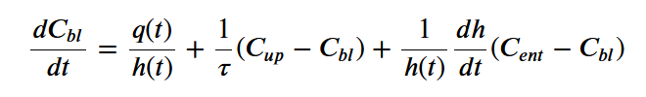

**Equation 1**: The Box Model Differential Equation

**Methods:**

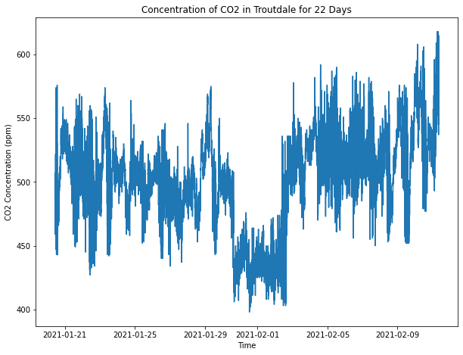Data gathering was achieved by using a Telaire T6713 NDIR CO2 sensor controlled by a WIFI enabled ESP8266. Atmospheric CO2 data was gathered every 15 seconds and then recorded by taking a minute by minute average. This data gathering elapsed 22 days and provided over 30,000 data points. Data analysis was done primarily in the python package Pandas. A column was created to calculate the anomaly values between the daily mean of the CO2 reading and CO2 reading itself, this provided a more normalized snapshot of the CO2 data since the day to day fluctuations of CO2 were not relevant to the study, only the daily fluctuations hour by hour. All anomaly data points that were more than 2.5 standard deviations away from the mean were then discarded.

**Fig 1:** 22 Days of CO2 Data in Troutdale

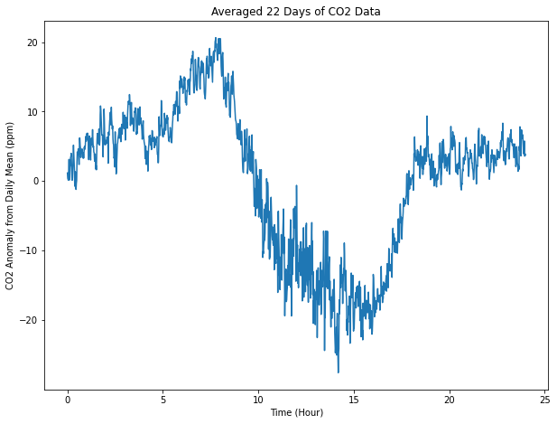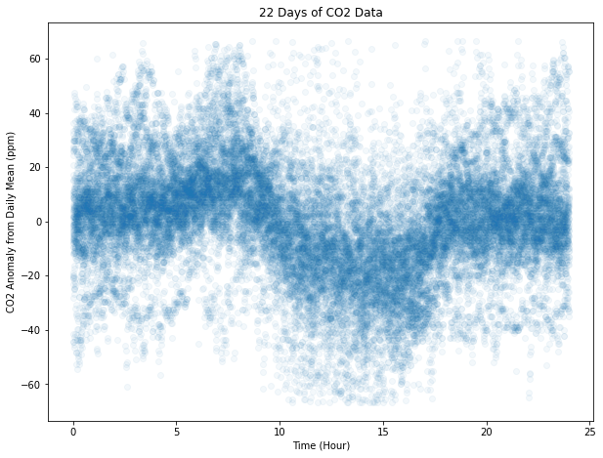

**Fig 2:** Anomaly Values of Daily CO2

**Fig 3:** Mean Value of Anomaly Values

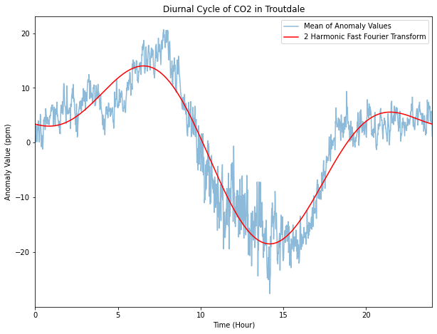Once the data was cleaned it was visualized using matplotlib first to show the total datapoints over the course of the 22 days (Fig 1) and then a daily total of all the data points with the time of day they were gathered mapped with their anomaly values (Fig 2). The mean value for each minute of data points was then taken both to reduce the total amount of data points and prepare it for the fast Fourier transform (fft). These averaged values were then repeated 50 times to create a sinusoidal "wave" of data that could then be analyzed by numpy's rfft function (Fig 3). After the fft was taken all but the first two harmonics were discarded and the inverse fft was then executed to produce the sinusoidal wave that shown in Figure 4.

**Fig 4:** Diurnal Cycle of CO2 in Troutdale with FFT

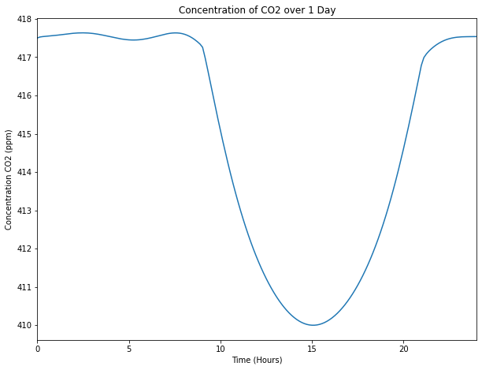The second part of the project involved a box model differential equation (Eq. 1) to simulate the effect photosynthesis and the boundary layer play in the diurnal cycle of CO2. The model consisted of three parts, the anthropogenic and photosynthesis factor, the changing height of the boundary layer, the wind going into and out of the box, and the entrainment of the upper boundary of the box. The photosynthesis factor and the changing height of the boundary layer both changed to where they peaked during the heat of the day and was lower and absent during the nighttime. Applying the differential equation to a fourth order runge kutta, the differential equation showed the diurnal cycle of CO2 and the effect that anthropogenic sources and photosynthesis play on it (Fig 5).

**Fig 5:** Box Model Concentration of CO2

**Results:**

As seen in Figure 4 and 5, CO2 fluctuates by several ppm throughout the day with the highest value being during the night and early morning and the lowest values being around 3pm where the day is at its warmest. Figure 4 however, does have some distinctions and features that were not accounted for in the box model solution. There is a spike in the concentration in the early morning for Figure 4 that is not in Figure 5. The reason for this is currently outside the scope of this project. However, both figures show a sharp plunge in concentration around the time that the sun would come up in the late morning (since it is in January and February).

The box model was subject to scrutiny however, when the photosynthesis parameter was removed, the diurnal cycle only fluctuated by slightly over 2 ppm. However, the size of anthropogenic CO2 seems to be linearly related to the amount the concentration changes over the where the fluctuation halves or doubles depending on if the anthropogenic CO2 value halves or doubles. Furthermore, the wind speed also plays a large role in the diurnal fluctuation of CO2. Reducing the wind speed from 3 to 1 m/s more than triples the differences between the peaks and valleys of the figure. One issue that occurred when running this program was an overflow error that happened when the wind speed was increased past 4 meters per second which was detrimental to the project because it was unable to determine how much the fluctuations dissipates when wind speeds are high.

**Conclusions:**

The diurnal cycle of CO2 is very apparent in this project and based on the box model that was tested for, it is clear that it can be attributed mainly towards the fluctuations in the height of the atmospheric boundary layer as well as the rate at which photosynthesis changes throughout the day. In the real world, anthropogenic sources would also fluctuate throughout the day, whether it be from rush hour, people turning off and on their heating units as it gets colder, or simply the overall increased human interaction with the world that happens during the day.

Moving forward, it would be useful to get sounding data from local sources to compare the atmospheric boundary layer height with the temperature and the concentration of CO2. Additionally, it would be interesting to look at how much traffic and rush hour play a role in the fluctuation of CO2 throughout the day. The data was gathered during a part of Covid-19 when there was not much traffic on the roads and there might be a difference in values or shape of the graph now that traffic has returned.

**Works Cited:**

Ono, Shuhei. *Box Model for CO2 in an Urban Atmosphere*, MIT OCW, Oct. 2013, ocw.mit.edu/courses/earth-atmospheric-and-planetary-sciences/12-335-experimental-atmospheric-chemistry-fall-2014/labs/MIT12_335F14_Box_model.pdf.

Rice, Andrew, and Gregory Bostrom. “Measurements of Carbon Dioxide in an Oregon Metropolitan Region.” *Atmospheric Environment*, vol. 45, no. 5, 2011, pp. 1138–1144., doi:10.1016/j.atmosenv.2010.11.026.

Xueref-Remy, Irène, et al. “Diurnal, Synoptic and Seasonal Variability of Atmospheric CO2 in the Paris Megacity Area.” *Atmospheric Chemistry and Physics*, vol. 18, no. 5, 2018, pp. 3335–3362., doi:10.5194/acp-18-3335-2018.

Zhang, Yuanjie, et al. “Diurnal Climatology of Planetary Boundary Layer Height Over the Contiguous United States Derived From AMDAR and Reanalysis Data.” *Journal of Geophysical Research: Atmospheres*, vol. 125, no. 20, 2020, doi:10.1029/2020jd032803.